# Appendix -3: Facility Numbers

|  |  |  |  |
| --- | --- | --- | --- |
| **#** | **Program Title** | **Submitting Hospital** | **Facility Number** |
| 2 | a) Sarcoma (Chemotherapy)  b) Sarcoma (Pathology)  c) Sarcoma (Prosthesis) | The Ottawa Hospital | 958 |
| Sinai Health System | 976 |
| Hamilton Health Sciences Corporation | 942 |
| London Health Sciences | 936 |
| University Health Network | 947 |
| Kingston General Hospital | 693 |
| Lakeridge | 952 |
| Royal Victoria Regional Health Center | 606 |
| Grand River Health Corporation | 930 |
| Windsor Regional Center | 933 |
| Sunnybrook Health Sciences Centre | 953 |
| London Health Sciences | 936 |

# Appendix -11: Valid 2-digits Postal Codes

(Source: Cancer Care Ontario's Data Book - 2012-2013, Appendix B - Province and State codes, at link https://www.cancercare.on.ca/ext/databook/db1213/databook.htm).

The table below provides list of valid 2 digit postal codes for province and State codes.

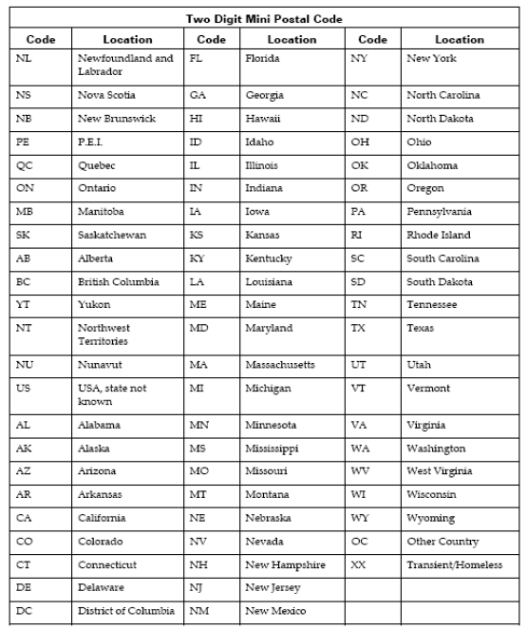

# Appendix-14 Valid Drug Names

|  |  |
| --- | --- |
|  | **Valid Drug Names** |
|  | Cisplatin |
|  | Cyclophosphamide |
|  | Docetaxel |
|  | Doxorubicin |
|  | Epirubicin |
|  | Etoposide |
|  | Gemcitabine |
|  | High Dose Ifosfamide |
|  | High Dose Methotrexate |
|  | Ifosfamide |
|  | Mesna |
|  | Methotrexate |
|  | Other |
|  | Topotecan |
|  | Vinblastine |
|  | Vincristine |
|  | Cisplatin |

# Appendix-22 Pharmaceutical dose unit

This table provides info for Radio pharmaceutical dose unit

| **Unit Code** | **Description** |
| --- | --- |
| cap | capsule |
| MBq | megabecquerels |
| mcg | microgram |
| mEq | milliequivalent |
| MU | million units |
| tab | tablet |
| unit | unit |
| mg | milligram |
| mL | milliliter |
| drop | drop |
| pfu | plaque forming unit |
| cm | centimeter |
| g | gram |
| loz | lozenge |
| mmol | millimoles |
| part | particle |
| ptch | patch |
| pkt | packet |
| pop | popsicle |
| puff | puff |
| spry | spray |
| supp | suppository |

# Appendix -23 Regimen List

A set of anti-cancer and supportive medications given during an active course of systemic chemotherapy that is named and defined in CCO's Provincial Formulary Regimen List.

| **Regimen Name** | **Description** |
| --- | --- |
| CISPDOX-MTRX(HD) | OSTEOGENIC SARCOMA (CISPLATIN,DOXORUBICIN,METHOTREXATE) |
| CYCLTOPO | SARCOMA OR NEUROBLASTOMA - TOPOTECAN, CYCLOPHOSPHAMIDE |
| DOCEGEMC | GI,PANCREAS OR LUNG,NSCLC OR GU,BLADDER OR GYNECOLOGICAL OR BREAST OR HEMATOLOGY OR HEAD AND NECK OR SARCOMA - GEMCITABINE, DOCETAXEL |
| DOXOIFOS | SARCOMA OR GYNECOLOGICAL, IFOSFAMIDE-DOXORUBICIN (+ MESNA) |
| EPIRIFOS | SOFT TISSUE SARCOMA (IFOSFAMIDE,EPIRUBICIN,MESNA) |
| ETOPIFOS | SARCOMA, IFOSFAMIDE-ETOPOSIDE (MAY USE MESNA) |
| GEMC | GI,PANCREAS OR LUNG,NSCLC OR GU,BLADDER OR GYNECOLOGICAL OR BREAST OR HEMATOLOGY OR HEAD AND NECK OR SARCOMA - GEMCITABINE |
| IFOS | SARCOMA OR GYNECOLOGICAL OR GENITOURINARY, IFOSFAMIDE (+ MESNA) |
| MTRX(HD) | GYNECOLOGICAL - GESTATIONAL TROPHOBLASTIC NEOPLASIA OR HEMATOLOGY OR SARCOMA OR UNKNOWN OR CNS, METHOTREXATE (> OR = 100MG/M2)) |
| MTRXVINO | SARCOMA -SOFT TISSUES, VINORELBINE - METHOTREXATE |
| MTRXVNBL | SARCOMA -SOFT TISSUES, VINBLASTINE - METHOTREXATE |
| VAC | GYNECOLOGIC SARCOMA (vinCRIStine; DOXOrubicin; Cyclophosphamide) |
| CISPDOX-MTRX(HD) | OSTEOGENIC SARCOMA (CISPLATIN,DOXORUBICIN,METHOTREXATE) |